PROCUREMENT DEPARTMENT

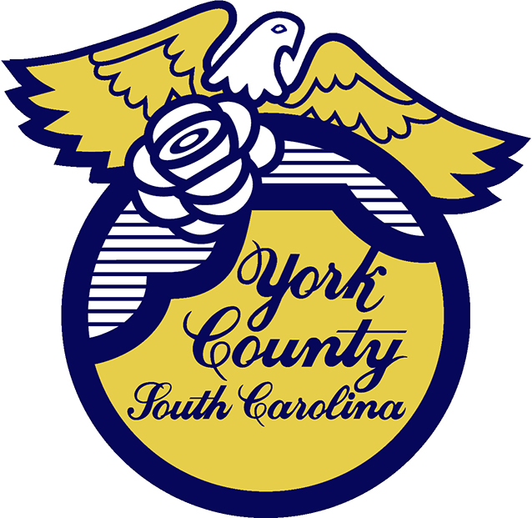

Memo To: All Bidders of York County Bid# 2905/ 1/10/2024

From: Teria G. Sheffield, Procurement Director

Subject: Solicitation Awarded

Date: March 18, 2024

Solicitations were received on January 10, 2024 for Prequalified Water and Sewer Repair Services.

During its March 18, 2024 meeting, the County Council approved a contractual agreement regarding RFP #2905 for pre-qualified contractors to provide various water and sewer repairs, maintenance, and technical services for the York County Water and Sewer Department. Approval included the following vendors:

*AAA City Plumbing, Inc. of Rock Hill SC,
*Atlantic Coast Contractors of Denver NC,
*Carolina Lift Stations of York SC,
*M&E Welding LLC of Union SC,
*Fuller and Co. Construction of Crouse NC
*State Utility Contractors, Inc. of Monroe NC.

We sincerely appreciate your time involved in submitting a bid.

2905val
TGS/jc

PO Box 180, 6 South Congress Street, York, SC 29745
Telephone: 803-684-8520 Fax: 803-684-8580 Web: www.yorkcountygov.com

