PROCUREMENT DEPARTMENT

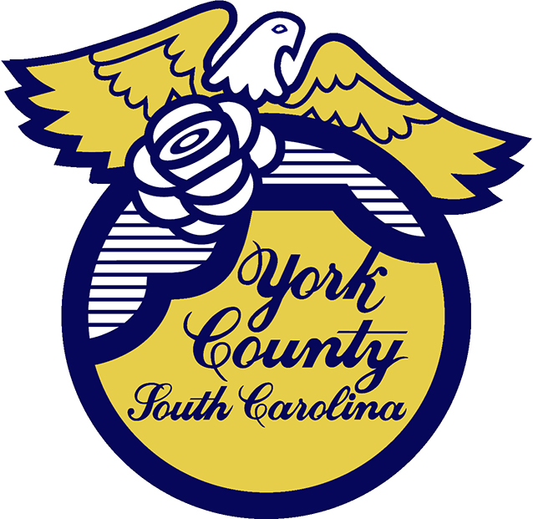

Memo To: All Bidders of York County Bid# 2902/ 12-12-2023

From: Teria G. Sheffield, Procurement Director

Subject: Proposal Awarded

Date: January 16, 2024

Sealed Proposals were received on December 12, 2023 for the Phase 1 North-South Water Transmission Main Harper Road Project. The County Council approved award to State Utility Contractors Inc. of Monroe, NC.
.
We sincerely appreciate your time involved in submitting a proposal.

2902val
TGS/ka

PO Box 180, 6 South Congress Street, York, SC 29745
Telephone: 803-684-8520 Fax: 803-684-8580 Web: www.yorkcountygov.com

