Memo To: All Bidders of York County
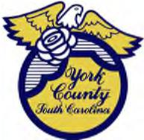 | PROCUREMENT DEPARTMENT

RFQ-2912
From: Teria G. Sheffield, Procurement Director
Subject: Contract Negotiations
Date: 05/21/2024

Solicitations for RFQ 2912 were received on March 12, 2024. County Council authorized contract negotiations to perform professional engineering services for various solid waste management and environmental monitoring services on May 20, 2024.
Status of negotiations are updated as soon as they become available. You are encouraged to check the York County website at York, SC | Official Website (yorkcountygov.com).
We sincerely appreciate your time involved in submitting a solicitation.

2912cn
TGS/ka

PO Box 180, 6 South Congress Street, York, SC 29745
Telephone: 803-684-8520 Fax: 803-684-8580 Web: www.yorkcountygov.com

