PROCUREMENT DEPARTMENT

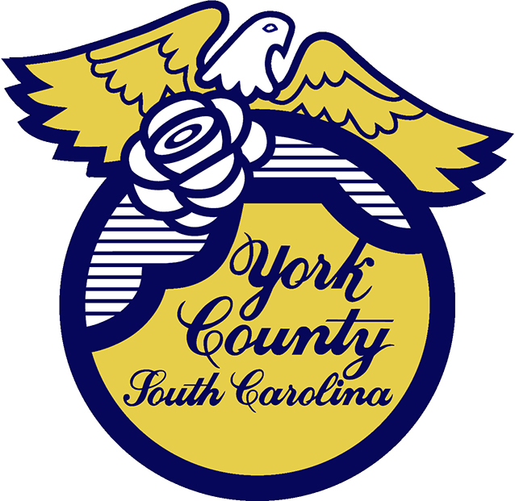

Memo To: All Bidders of York County IFB# 2915/ 3-28-2024

From: Teria G. Sheffield, Procurement Director

Subject: Bid Awarded

Date: May 10, 2024

Sealed Bids were received on March 28, 2024 for Clearing and Grubbing of US 21 Bypass and SC 51.

During the May 6, 2024 meeting, the County Council awarded this bid to NJR Group, Inc. of Albemarle NC

We sincerely appreciate your time involved in submitting a bid.

2915val
TGS/jc

PO Box 180, 6 South Congress Street, York, SC 29745
Telephone: 803-684-8520 Fax: 803-684-8580 Web: www.yorkcountygov.com

