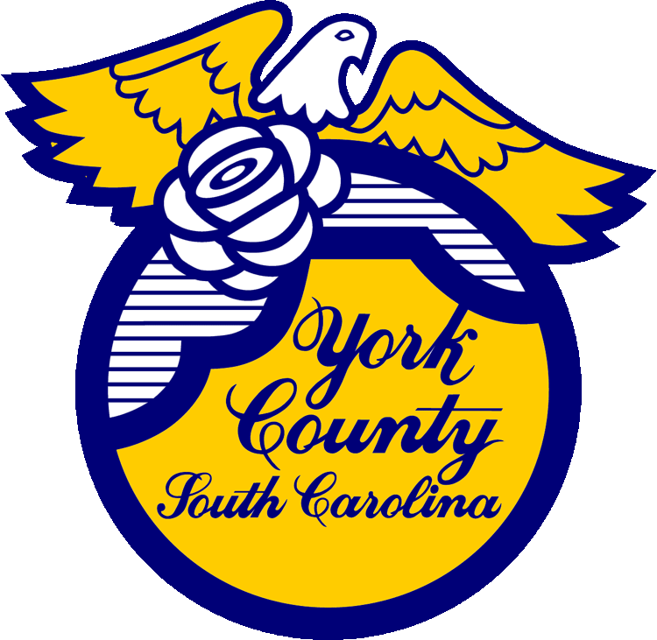
__________ York County Procurement Department

Memo To: All Bidders of York County Bid# 3015

From: Teria G. Sheffield, Procurement Director

Subject: Proposal Awarded

Date: May 4, 2026

Sealed Proposals were received on September 17, 2025 to provide Engineering Services associated with Highway 557 Sewer Upgrade Design. The County Council approved an engineering contract with LaBella Associates of Charlotte NC.
.

We sincerely appreciate your time involved in submitting a proposal.

3015val
TGS/jc

York County Procurement Department
6 South Congress Street, Post Office Box 180, York, S.C. 29745
Phone: (803) 684-8520 Website: www.yorkcountygov.com

