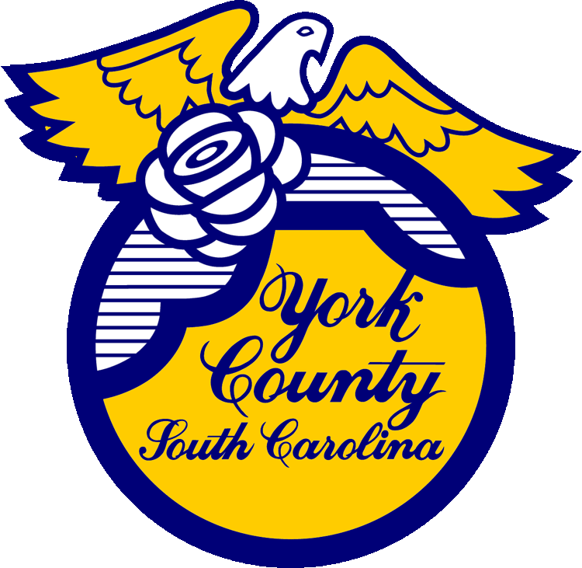
__________ York County Procurement Department

Memo To: All Bidders of York County Bid# 3032/ 04-01-2026

From: Teria G. Sheffield, Procurement Director

Subject: Proposal Awarded

Date: June 22, 2026

Sealed Proposals were received on April 1, 2026 for Dumpster Services for York County facilities and Culture and Heritage Museums of York County. The County Council approved award to the lowest responsive and responsible bidder to Republic Services of Fort Mill, SC.

We sincerely appreciate your time involved in submitting a proposal.

3032val
TGS/ka

York County Procurement Department
6 South Congress Street, Post Office Box 180, York, S.C. 29745
Phone: (803) 684-8520 Website: www.yorkcountygov.com

