PROCUREMENT DEPARTMENT

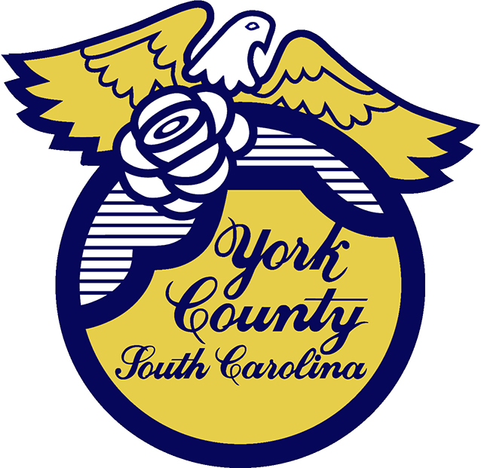

Memo To: All Bidders of York County BID# 2855/ 03-16-2023

From: Teria G. Sheffield, Procurement Director

Subject: Proposal Awarded

Date: September 6, 2023

Sealed Proposals were received on March 16, 2023 for York County Water and Sewer Bill. The County Council approved award to the lowest responsive and responsible bidder with Envelopes and Forms, Inc, SureBill of Duluth, GA.

We sincerely appreciate your time involved in submitting a proposal.

2855val
TGS/ka

PO Box 180, 6 South Congress Street, York, SC 29745
Telephone: 803-684-8520 Fax: 803-684-8580 Web: www.yorkcountygov.com

