PROCUREMENT DEPARTMENT

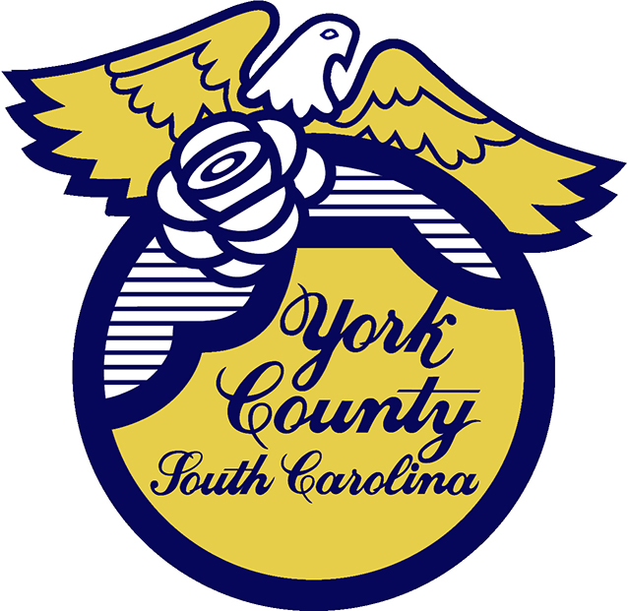

Memo To: All Bidders of York County Bid# 2884/ 08-02-2023

From: Teria G. Sheffield, Procurement Director

Subject: Proposal Awarded

Date: January 24, 2024

Sealed Proposals were received on August 2, 2023 for the Progressive Design-Build Services for Improvements to Field Day Park in York County. The County Council approved award to J.D. Goodrum Company, Inc., Cornelius NC.
.

We sincerely appreciate your time involved in submitting a proposal.

2884val
TGS/ka

PO Box 180, 6 South Congress Street, York, SC 29745
Telephone: 803-684-8520 Fax: 803-684-8580 Web: www.yorkcountygov.com

