PROCUREMENT DEPARTMENT

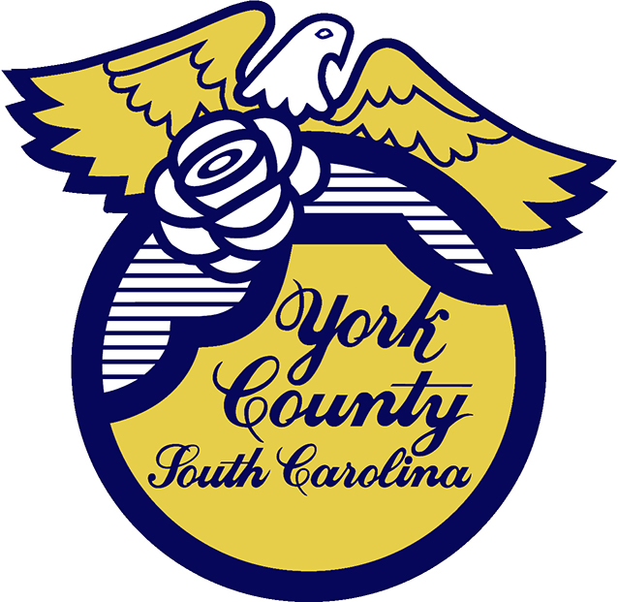

Memo To: All Bidders of York County Bid# 2886/ 08-16-2023

From: Teria G. Sheffield, Procurement Director

Subject: Proposal Awarded

Date: February 19, 2024

Sealed Proposals were received on August 16, 2023 for Progressive Design Build Catawba Bend Preserve One-mile Greenway Trail Project in York County. The County Council approved award to J.D. Goodrum Company Inc. of Cornelius, NC.

We sincerely appreciate your time involved in submitting a proposal.

2886val
TGS/ka

PO Box 180, 6 South Congress Street, York, SC 29745
Telephone: 803-684-8520 Fax: 803-684-8580 Web: www.yorkcountygov.com

