PROCUREMENT DEPARTMENT

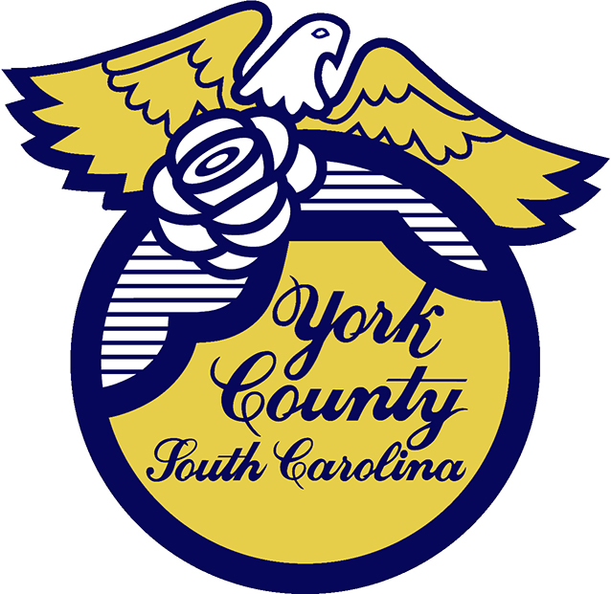

Memo To: All Bidders of York County/ IFB 2891

From: Teria G. Sheffield, Procurement Director

Subject: Bid Awarded

Date: October 17, 2023

Sealed Bids were received on September 5, 2023 for Ammonium Calcium Nitrate for Odor and Corrosion Control for Waste Water Systems for use by the York County Water and Sewer Department. The County Council awarded this bid to Southern Environmental System of Fort Mill SC.

We sincerely appreciate your time involved in submitting a bid.

2891val
TGS/jc

PO Box 180, 6 South Congress Street, York, SC 29745
Telephone: 803-684-8520 Fax: 803-684-8580 Web: www.yorkcountygov.com

